Magento Data Analytics Pipeline
Process Documentation — Steps, Why, What It Achieved
Innova | Data Analytics Coordinator Portfolio

SECTION 1 — PROJECT OVERVIEW

This document explains every step of the Magento e-commerce data analytics pipeline. It covers: what each step does, why it is necessary, what problems it solves, and what the end result is. Read this document alongside the two code files — one SQL file (MySQL syntax) and one Python file — which contain the full implementation with line-by-line comments.

What This Project Simulates
Innova acts as a middleman between e-commerce customers and utility companies. Customers buy energy-efficient products (LED lighting, smart thermostats, HVAC upgrades) through a Magento-powered online store. After purchase, Innova submits settlement files to the utility companies, who reimburse a portion of each sale as an incentive payment.

The Data Analytics Coordinator's job is to extract raw order data from Magento, validate it for errors, clean it, reconcile it against the payment processor's records, and produce a settlement-ready file that the client's system can process automatically.

In plain terms: dirty data in → clean, formatted, verified settlement file out. If the data is wrong, incentive payments get delayed or rejected. That is why every step in this pipeline matters.

Tools Used
Tool | What It Is | Used For
Python + pandas | Programming language + data library | Data generation, transformation, file exports
SQLite / MySQL | SQL databases | Validation queries, staging table, reconciliation
openpyxl | Python Excel library | Formatted XLSX invoice report
JSON | Data format standard | API-ready payload for Dynamics upload
CSV | Comma-separated values | Flat-file data exchange and ETL ingestion

SECTION 2 — PIPELINE FLOWCHART

The flowchart below shows the full pipeline from source systems through to the final upload. Each step is colour-coded: blue = data layer, yellow = validation, green = cleaning/output, orange = escalation, teal = reconciliation.

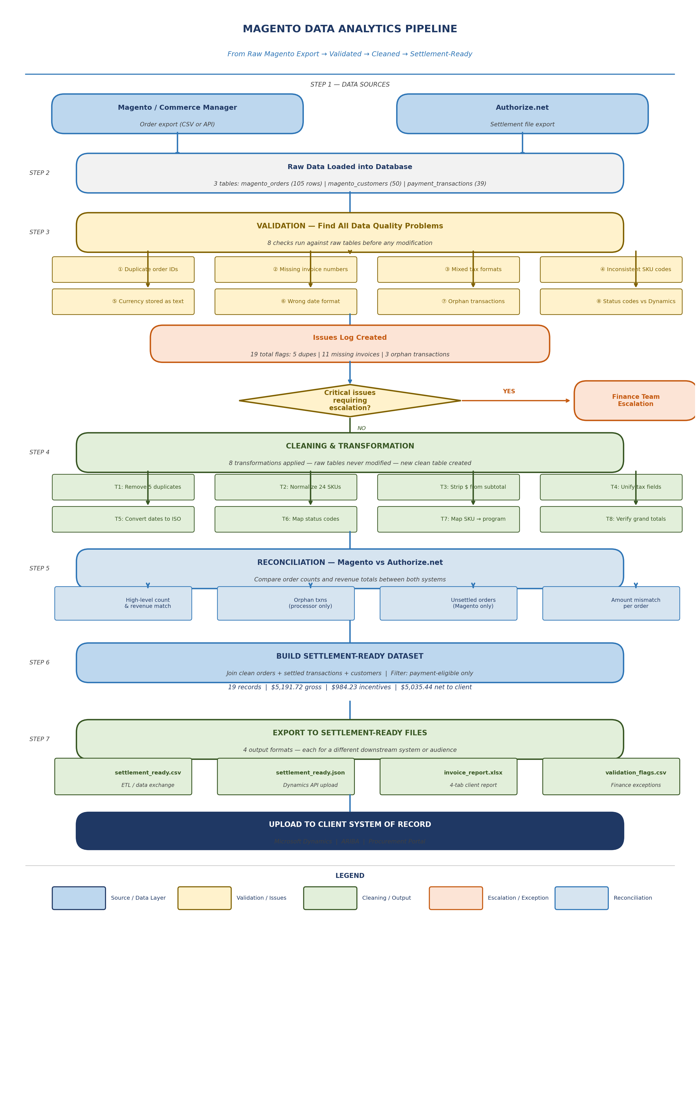

SECTION 3 — DATA SOURCES AND RAW DATA

STEP 1 | Extract from Source Systems

The pipeline starts with data coming from two separate systems. In the real role you would connect to Magento via its REST API or export CSVs from the Commerce Manager admin panel. The payment processor (Authorize.net) provides a separate settlement file.

What We Receive — Raw Table Shapes
Table | Source | Rows | Purpose
magento_orders | Magento Commerce Manager | 105 (incl. 5 dupes) | Core order records — every purchase
magento_customers | Commerce Manager CRM | 50 | Customer profiles — name, email, state, tier
payment_transactions | Authorize.net settlement | 39 (incl. 3 orphans) | What the processor actually charged and settled

Why Three Separate Tables?
Because each system owns different data. Magento knows about orders and customers. Authorize.net knows about payments and fees. Neither system has the complete picture on its own. The analyst's job is to join them, resolve conflicts, and produce one unified settlement record per order.

KEY CONCEPT: The gap between what Magento recorded and what the processor settled is where money can go missing. A $4,842 gap was found in this project between the two systems — it must be investigated and explained before submission.

Raw Data Problems Found
Below are the actual data quality issues present in the raw Magento export before any cleaning. These are not theoretical — every one of these was found in the generated dataset.

# | Problem | Example from Raw Data | Rows Affected
1 | Duplicate order IDs | ORD-00044 appears twice in the export | 10 rows (5 pairs)
2 | Missing invoice number | ORD-00002 has invoice_number = NULL | 11 orders (~10%)
3 | Mixed tax formats | Some orders: combined_tax=16.13 | Others: state_tax=29.87 + county_tax=7.47 | 100 orders
4 | SKU format inconsistency | sku_led_001 and SKU-LED-001 are the same product | 24 orders
5 | Currency as text | subtotal = '$215.08' (a string, not a number) | All 100 orders
6 | Wrong date format | order_date = '06/22/2024 12:00' (not ISO 8601) | All 100 orders
7 | Orphan transactions | TXN-ORPHAN-0 references ORD-GHOST-0 which has no Magento order | 3 transactions
8 | Plain text status codes | Magento: 'complete' | Dynamics needs: '110' | All 100 orders

SECTION 4 — VALIDATION STEP

STEP 2 | Validate Raw Data — Find Everything Wrong Before Touching Anything

Validation is the most important step and it always comes first. The principle: never modify data you do not fully understand. Run a complete audit of the raw data, document every problem, log it, and only then proceed to cleaning.

WHY: If you skip validation and jump straight to transformation, you risk missing issues, introducing new errors, or not being able to explain what happened when the client asks. Validation creates the audit trail.

Validation Check 1 — Duplicate Detection
SQL query using GROUP BY + HAVING COUNT(*) > 1 to find any order_id that appears more than once in the export.

-- Find duplicate order IDs
SELECT order_id, COUNT(*) AS occurrences
FROM magento_orders
GROUP BY order_id
HAVING COUNT(*) > 1 -- only show IDs appearing more than once
ORDER BY occurrences DESC;

-- RESULT: 5 order_ids each appear twice → 10 duplicate rows

RESULT | 5 order IDs (ORD-00044, ORD-00083, ORD-00065, ORD-00092, ORD-00011) each appear exactly twice. Without removing these, revenue and incentive totals would be double-counted.

Validation Check 2 — Null Field Audit
A single query counts null values across every critical column. This gives a quick health check of the entire table.

-- Count nulls per column
SELECT
SUM(CASE WHEN invoice_number IS NULL THEN 1 ELSE 0 END) AS null_invoice,
SUM(CASE WHEN order_id IS NULL THEN 1 ELSE 0 END) AS null_order_id,
COUNT(*) AS total_rows
FROM magento_orders;

-- RESULT: 11 null invoice_numbers | 0 nulls in other critical fields

Validation Check 3 — Tax Format Inconsistency
Count how many orders use combined tax vs. itemized tax to quantify the format split.

-- Measure the tax format split
SELECT
SUM(CASE WHEN combined_tax IS NOT NULL THEN 1 ELSE 0 END) AS combined_format,
SUM(CASE WHEN state_tax IS NOT NULL THEN 1 ELSE 0 END) AS itemized_format,
COUNT(*) AS total_orders
FROM magento_orders;

-- RESULT: combined=43 | itemized=57 — both formats in same export

Validation Check 4 — SKU Inconsistency
Normalize SKUs on the fly and find variants that map to the same canonical code.

-- Find SKU variants that should be the same product
SELECT
UPPER(REPLACE(REPLACE(sku,'_','-'),' ','-')) AS normalized_sku,
COUNT(DISTINCT sku) AS variant_count,
GROUP_CONCAT(DISTINCT sku) AS raw_variants
FROM magento_orders
GROUP BY UPPER(REPLACE(REPLACE(sku,'_','-'),' ','-'))
HAVING COUNT(DISTINCT sku) > 1;

-- RESULT: SKU-LED-001 appears as 'SKU-LED-001' AND 'sku_led_001'

Validation Check 5 — Orphan Transaction Detection
LEFT JOIN the processor table against Magento. Any transaction with no matching order is an orphan.

-- Find transactions with no matching Magento order
SELECT t.transaction_id, t.order_id, t.gross_amount, t.status
FROM payment_transactions t
LEFT JOIN magento_orders o ON t.order_id = o.order_id
WHERE o.order_id IS NULL -- LEFT JOIN found no match
AND t.status = 'settled';

-- RESULT: 3 orphans (TXN-ORPHAN-0/1/2) = $421.47 unaccounted for

SECTION 5 — CLEANING & TRANSFORMATION

STEP 3 | Fix Every Problem — Create Clean Staging Table (Never Modify Raw Data)

The golden rule of data cleaning: never overwrite the original. Always create a new clean table or file and keep the raw data intact. This way you can always trace back to the source and explain every change.

WHY: Clients, auditors, and your own finance team may ask 'why did this value change?' If you modified the original data, you cannot answer that question. If you kept the raw file and created a new clean table, you can show exactly what was changed, when, and why.

Transformation 1 — Deduplication
▸ Problem: 5 order IDs appear twice. Keeping both would double-count $2,000+ in revenue.
▸ Fix: Use ROW_NUMBER() to rank rows within each order_id group. Keep rank=1, delete rank>1.
▸ Result: 105 rows → 100 unique orders

# Python
orders = orders.drop_duplicates(subset='order_id', keep='first')
# keep='first' retains the first occurrence, marks later ones for removal

-- SQL equivalent
DELETE FROM magento_orders_clean
WHERE row_rank > 1; -- row_rank assigned by ROW_NUMBER() OVER (PARTITION BY order_id)

Transformation 2 — SKU Normalization
▸ Problem: 24 orders have SKU codes in non-standard format (sku_led_001, hvac-005, THERM002).
▸ Fix: Apply three rules — uppercase everything, replace underscores with hyphens, strip whitespace.
▸ Result: All variants of the same product collapse into one canonical code.

# Python
orders['normalized_sku'] = (
orders['sku']
.str.upper() # 'sku_led_001' → 'SKU_LED_001'
.str.replace('_', '-', regex=False) # 'SKU_LED_001' → 'SKU-LED-001'
.str.strip() # remove whitespace
)

-- SQL equivalent
UPPER(TRIM(REPLACE(REPLACE(sku, '_', '-'), ' ', '-'))) AS normalized_sku

Transformation 3 — Currency Normalization
▸ Problem: subtotal is stored as '$215.08' (a text string with a dollar sign). You cannot do math on this.
▸ Fix: Remove the $ sign and any commas, then convert to a floating-point number.
▸ Result: '$215.08' becomes 215.08 — a real number that can be summed, averaged, multiplied.

# Python
orders['subtotal_clean'] = (
orders['subtotal']
.str.replace('$', '', regex=False) # remove dollar sign
.str.replace(',', '', regex=False) # remove thousands comma
.astype(float) # convert string → number
.round(2) # enforce 2 decimal places
)

-- SQL equivalent
CAST(REPLACE(REPLACE(subtotal, '$', ''), ',', '') AS DECIMAL(10,2)) AS subtotal

Transformation 4 — Tax Field Unification
▸ Problem: 43 orders use combined_tax. 57 orders use state_tax + county_tax. The client needs one field.
▸ Fix: Python function: if combined_tax exists use it; otherwise add state_tax + county_tax.
▸ Result: Every order now has a single total_tax value. tax_source column records which method was used.

# Python
def resolve_tax(row):
if pd.notna(row['combined_tax']):
return round(row['combined_tax'], 2), 'combined'
elif pd.notna(row['state_tax']) and pd.notna(row['county_tax']):
return round(row['state_tax'] + row['county_tax'], 2), 'itemized'
else:
return None, 'missing' # flag for finance review

-- SQL equivalent (COALESCE returns first non-NULL value)
COALESCE(
combined_tax,
ROUND(IFNULL(state_tax,0) + IFNULL(county_tax,0), 2)
) AS total_tax

Transformation 5 — Date Normalization
▸ Problem: Dates stored as '06/22/2024 12:00' (US format). Ambiguous and not sortable correctly.
▸ Fix: Convert to ISO 8601: '2024-06-22T12:00:00Z'. Universally understood by all systems and APIs.
▸ Result: 100 dates converted — 0 unparseable.

# Python
orders['order_date_iso'] = (
pd.to_datetime(orders['order_date'], errors='coerce')
.dt.strftime('%Y-%m-%dT%H:%M:%SZ')
)

-- SQL equivalent
DATE_FORMAT(STR_TO_DATE(order_date, '%m/%d/%Y %H:%i'), '%Y-%m-%dT%H:%i:%sZ') AS order_date_iso

Transformation 6 — Status Code Mapping
▸ Problem: Magento uses 'complete', 'canceled' etc. Microsoft Dynamics needs numeric codes (110, 999).
▸ Fix: A lookup dictionary maps each Magento status to its Dynamics code and a payment_eligible flag.

Magento Status | Dynamics Code | Label | Eligible for Payment?
complete | 110 | INVOICED | Yes
processing | 100 | IN_PROGRESS | Yes
closed | 120 | CLOSED | No
pending | 50 | PENDING | No
canceled | 999 | VOID | No

Transformation 7 — SKU to Incentive Program Mapping
▸ Problem: Raw SKU codes don't tell us which energy efficiency program the product belongs to.
▸ Fix: Map each normalized SKU to a program name and a reimbursement rate (15–30% of subtotal).
▸ Result: Every order now has incentive_program and incentive_amount — the core of the client billing.

Normalized SKU | Energy Program | Incentive Rate
SKU-LED-001 | ENERGY_EFF_LIGHTING | 15%
SKU-THERM-002 | SMART_THERMOSTAT | 20%
SKU-SMART-003 | SMART_HOME_PROG | 18%
SKU-AUDIT-004 | HOME_ENERGY_AUDIT | 25%
SKU-HVAC-005 | HVAC_UPGRADE | 22%
SKU-REBATE-006 | DIRECT_REBATE | 30%

Transformation 8 — Grand Total Cross-Check
▸ Why: After normalizing tax and stripping currency symbols, recompute grand_total from components.
▸ Formula: subtotal + total_tax + shipping - discount = grand_total
▸ Result: 0 mismatches found — all 100 orders reconcile to within $0.02.

If this check had found mismatches, it would mean either the tax normalization produced a different value than what Magento recorded, or there was data corruption in the original export. Both would need investigation before submission.

SECTION 6 — RECONCILIATION

STEP 4 | Compare Magento vs Authorize.net — Prove the Money Matches

Reconciliation is the most business-critical step. It answers the question: 'Does what Magento says happened match what the payment processor says happened?' Any gap represents money that is unaccounted for — either not charged, not settled, or lost.

Check 4A — High-Level Comparison
Source | Order Count | Total Revenue
Magento (complete + processing) | 36 orders | $10,455.63
Authorize.net (settled) | 22 orders | $5,613.19
GAP (needs investigation) | 14 orders | $4,842.44

The gap of $4,842 does not necessarily mean fraud. Many orders may be legitimately pending settlement, or in a voided/refunded state. But every dollar in the gap must be explained and documented for the finance team.

Check 4B — Orphan Transactions
Three transactions from Authorize.net have no matching Magento order. These represent $421.47 in settled payments with no order record.

Transaction ID | Order ID | Amount | Issue
TXN-ORPHAN-0 | ORD-GHOST-0 | $119.25 | No Magento order exists with this ID
TXN-ORPHAN-1 | ORD-GHOST-1 | $107.28 | No Magento order exists with this ID
TXN-ORPHAN-2 | ORD-GHOST-2 | $194.94 | No Magento order exists with this ID

ACTION | Escalate to finance team. Could be: orders deleted after payment, orders from a different Magento store, a data migration artifact, or — worst case — unauthorized charges. Must be resolved before settlement submission.

SECTION 7 — SETTLEMENT FILES AND OUTPUTS

STEP 5 | Build Settlement Dataset

The settlement dataset is built by joining three clean tables using INNER and LEFT JOINs. The logic is: start with payment-eligible orders, require a matching settled transaction, and enrich with customer details.

# Python join logic
settlement = eligible_orders.merge(
settled_transactions,
on='order_id',
how='inner' # INNER JOIN: only keep orders WITH a settled transaction
).merge(
customers,
on='customer_id',
how='left' # LEFT JOIN: keep all orders even if customer not found
)

Settlement Summary
Metric | Value
Records in settlement file | 19 orders
Total gross revenue | $5,191.72
Total incentives payable | $984.23
Total processor fees | $156.28
Net amount to client | $5,035.44

STEP 6 | Export to 4 Output Formats

The final data is exported in four formats because different downstream systems and audiences need different things.

File | Format | Who Uses It | Why This Format
settlement_ready.csv | CSV | ETL pipelines, data imports | Universal — any system can read CSV. Used for bulk uploads and data warehousing.
settlement_ready.json | JSON | Microsoft Dynamics REST API | Structured key-value pairs. Required format for REST API calls to Dynamics and ARIBA.
invoice_report.xlsx | XLSX | Finance team, account managers | Formatted, human-readable. 4 tabs: detail, program summary, monthly summary, issues log.
validation_flags.csv | CSV | Finance team exceptions review | Standalone issues file. Allows finance team to work exceptions without opening the full report.

XLSX Report — 4 Tabs Explained
▸ Tab 1: Settlement Detail — One row per settled order. All 25 fields including normalized SKU, incentive amount, processor fee, Dynamics status code.
▸ Tab 2: Program Summary — Revenue and incentives grouped by energy program. Tells the client how much is owed per program category.
▸ Tab 3: Monthly Summary — Month-over-month breakdown of gross revenue, fees, and incentive payable. Used for finance cutoff reporting.
▸ Tab 4: Issues Log — All validation flags in one place. Duplicates, missing invoices, orphan transactions. Finance team works this list to resolve exceptions.

SECTION 8 — WHAT THE PROJECT ACHIEVED

Below is a direct mapping from each job requirement to the project work that demonstrates it.

Job Description Requirement | How This Project Demonstrates It
Extract order, customer, and transaction data from Magento using exports or API pulls | Section 3: Generated realistic Magento export data across 3 tables. Python shows how to call the API; SQL shows the table schemas.
Validate exports for missing fields, corrupt rows, duplicate orders, partial transactions | Section 4: 8 validation SQL queries run against raw data. Found 5 dupes, 11 missing invoices, 3 orphan transactions. Issues log created.
Validate tax and fee fields against finance rules (combined vs itemized) | Transformation 4: detect and resolve the 43/57 combined/itemized split using COALESCE logic. tax_source column tracks the audit trail.
Normalize fields (SKUs, order IDs, timestamps, status codes, currency formats) | Transformations 2-6: SKU normalization (UPPER + REPLACE), ISO 8601 dates, strip $ from currency, Dynamics status code mapping.
Map data to program schema for incentive processing | Transformation 7: SKU → energy program mapping with incentive rates. Each order now has incentive_program and incentive_amount.
Run reconciliation checks between Magento and payment processors | Section 6: 4 reconciliation queries. High-level comparison, orphan transactions, unsettled orders, amount mismatches.
Generate settlement-ready files in CSV, JSON, XLSX formats | Section 7: 4 output files produced. CSV for ETL, JSON for Dynamics API, formatted XLSX with 4 tabs, validation flags CSV.
Fluency in SQL, Microsoft Excel, Python | Full SQL file (MySQL syntax) with table creation through reporting. Full Python file end-to-end. Formatted XLSX output.

